|  |  |  |
| --- | --- | --- |
| **LAB211 Assignment** | **Type:** | **Short Assignment** |
| **Code:** | **J1.S.P0008** |
| **LOC:** | **50** |
| **Slot(s):** | **1** |

**Title**

Letter and character count.

**Background Context**

Knowing the number of words or characters in a document can be important. For example, if the author is required to write a minimum or maximum amount of words for an article or paper, word counter can help them know if their article meets these requirements.

**Program Specifications**

Design a program that allows users to input the string value. Count and display the number of letters and characters

***Expectation of User interface:***

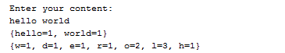

**Guidelines**

To tokenize a string, you can use StringTokenizer in java.util package